Student Id – IT24100778

Name – Jayakody J A K S S

Lab sheet 10

1

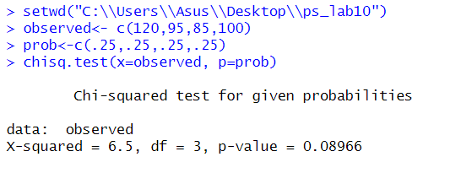

2

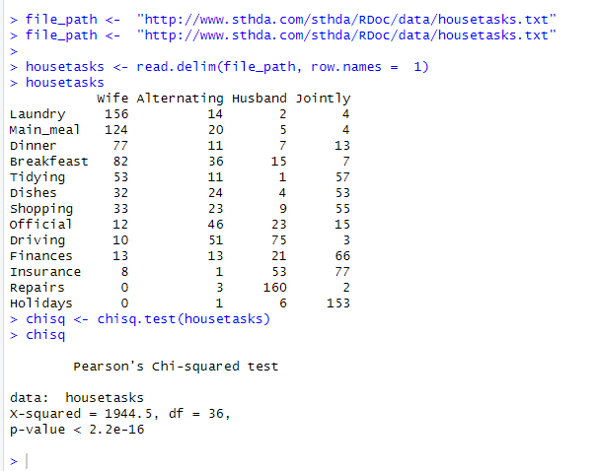

3

